Habits
And where it is written custom, it should be written specific days of the week and then the user selects like Monday, Tuesday and all that should go for forty days E:\edeen\src\features\home\screens\AddHabitScreen.js
- Make the frequency selection, Add an option to select a specific date for habits.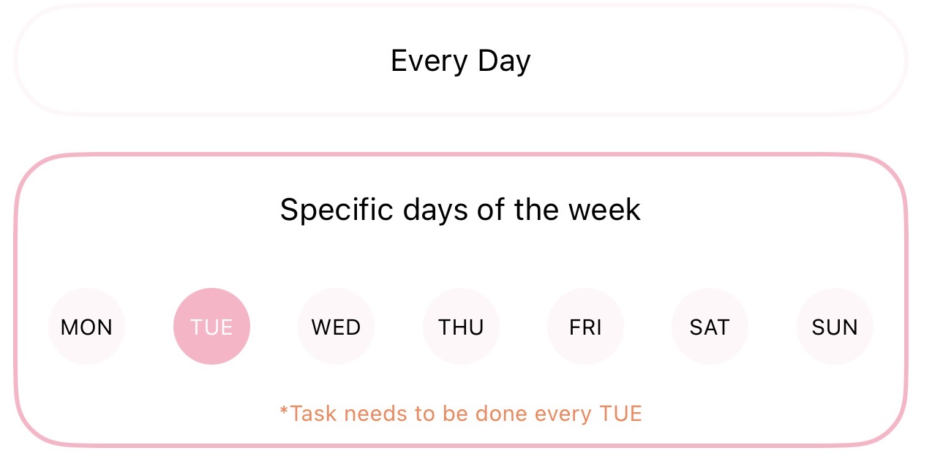

Interactions
- Add haptic feedback (vibration) when users tap clickable buttons.
- Review swipe gestures and make sure users are taken to the correct screens when swiping

fill the progress bars with the edeen light green

Journal Updates

Mood Section
- Remove the emotion labels/words displayed underneath the "How do you feel?" section.

Saving Entries
- Update journal colour scheme to match the colour of emotion

New Features to Add

Notifications

Implement push notifications for: Daily habits, Journal reminders

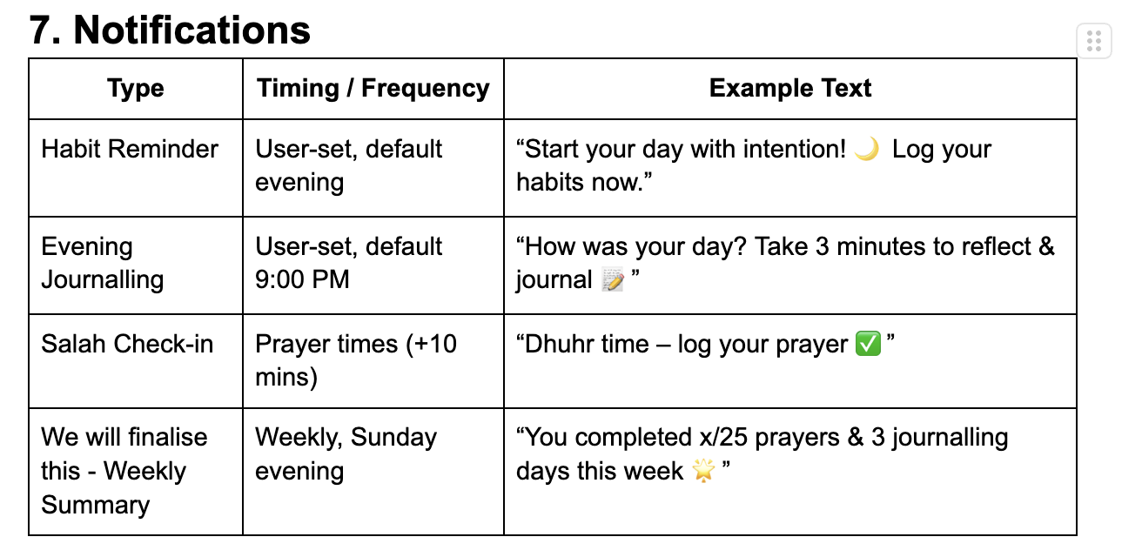

App Information Pages

Add onboarding screens explaining:

Purpose of the app

How to use each section

Quiz to tailor the app to the user

